**Project Report Format**

# 1. INTRODUCTION

## 1.1 Project Overview

This project aims to develop a Transfer Learning-based AI system for the automated classification of poultry diseases—specifically Salmonella, Newcastle Disease, Coccidiosis, and Healthy birds. By leveraging pre-trained deep learning models (e.g., CNNs like ResNet or EfficientNet), the system can accurately diagnose diseases using poultry images or symptom data, even with limited datasets.

The trained model will be integrated into a mobile or web application, enabling farmers to receive instant diagnoses and treatment suggestions. This solution is designed to enhance disease management, reduce mortality, and improve overall productivity and animal welfare in the poultry industry, especially in rural and resource-constrained areas.

## 1.2 Purpose

To develop an AI-driven system using transfer learning to identify common poultry diseases, such as:

* Salmonella
* Newcastle Disease
* Coccidiosis
* Healthy (no disease)

# 2. IDEATION PHASE

2.1 Problem Statement

2.2 Empathy Map Canvas

2.3 Brainstorming

# 3. REQUIREMENT ANALYSIS

3.1 Customer Journey map

3.2 Solution Requirement

3.3 Data Flow Diagram

3.4 Technology Stack

# 4. PROJECT DESIGN

4.1 Problem Solution Fit

4.2 Proposed Solution

4.3 Solution Architecture

1. **PROJECT PLANNING & SCHEDULING**
   1. Project Planning
2. **FUNCTIONAL AND PERFORMANCE TESTING**
   1. Performance Testing

# 7. RESULTS

7.1 Output Screenshots

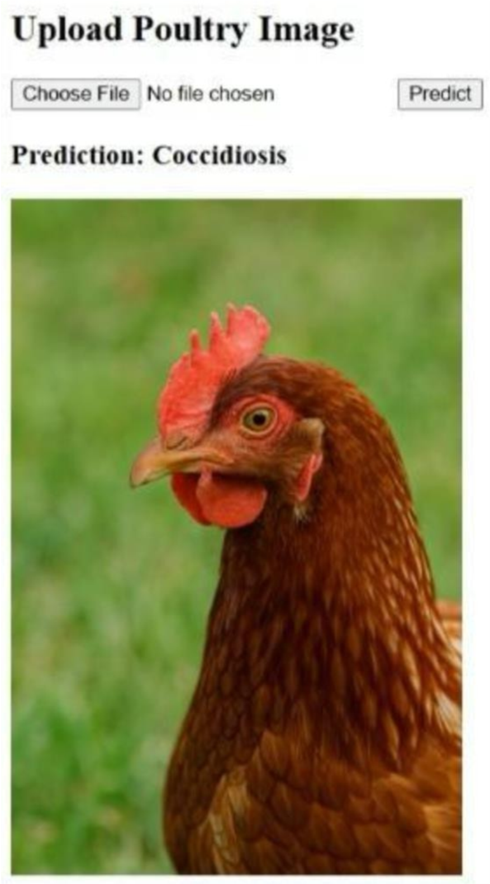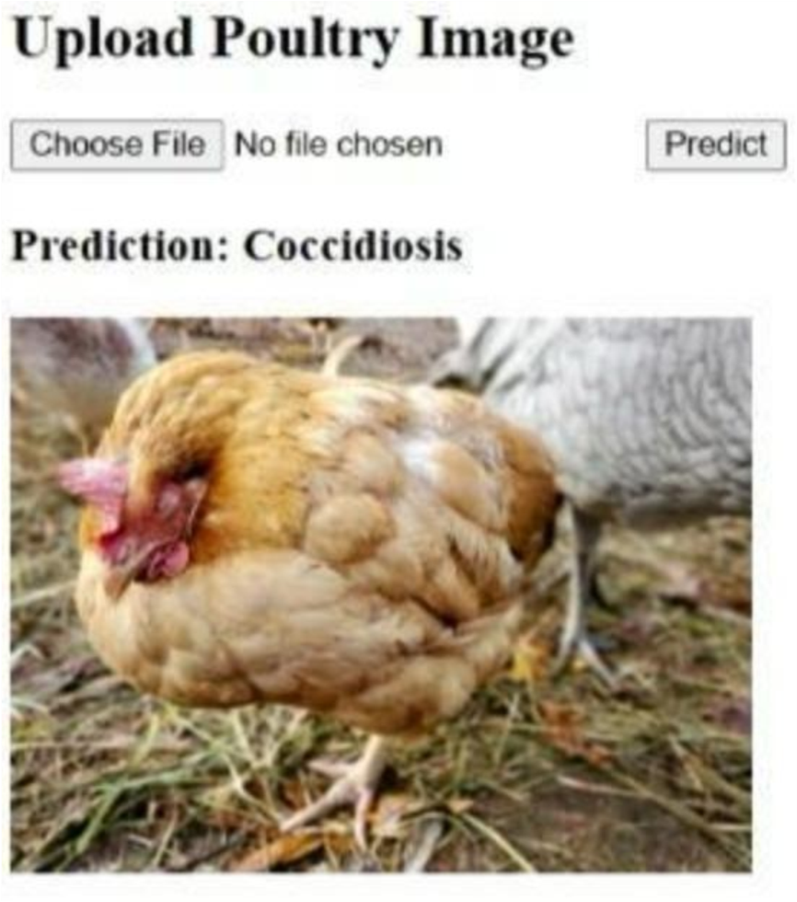

# 8. ADVANTAGES & DISADVANTAGES

**Advantages:**

 Needs less data

 Fast and accurate

 Low-cost diagnosis

 Easy to use

 Helps early disease detection

 Saves time

**Disadvantages:**

 Needs good image quality

 It may not work well with very different data

 Hard to understand how it makes decisions

 Requires regular updates

 May not run on low-end devices

 Needs updates

# 9. CONCLUSION

The use of transfer learning for poultry disease classification offers a smart, efficient, and accessible solution for improving poultry health management. By leveraging pre-trained deep learning models, the system can accurately identify common diseases like Salmonella, Newcastle Disease, and Coccidiosis, even with limited data. This approach empowers farmers with quick, low-cost, and reliable diagnosis tools, especially in rural areas. Overall, it promotes early treatment, reduces losses, and supports healthier, more productive poultry farming.

# 10. FUTURE SCOPE

 Add more poultry diseases for detection

 Use symptoms, sounds, and sensors for better diagnosis

 Enable real-time health monitoring with IoT

 Provide treatment tips and expert advice

 Support local languages and voice commands

 Link with veterinary health databases

 Improve model with privacy-friendly updates (federated learning)

 Expand use to other countries and regions

# 11. APPENDIX

**Source Code:(app.py)** from flask import Flask, render_template, request import os

from tensorflow.keras.models import load_model from tensorflow.keras.preprocessing import image import numpy as np

app = Flask(_name_)

# Load the trained model

model = load_model("healthy_vs_rotten.h5")

# Class names

class_names = ['Coccidiosis', 'Healthy', 'NewCastle', 'Salmonella']

# Prediction function def predict_disease(img_path):

img = image.load_img(img_path, target_size=(224, 224)) img_array = image.img_to_array(img) / 255.0 img_array = np.expand_dims(img_array, axis=0) prediction = model.predict(img_array) predicted_class = class_names[np.argmax(prediction)] return predicted_class

@app.route('/', methods=['GET', 'POST']) def index():

if request.method == 'POST': file = request.files['image'] if file:

filepath = os.path.join('static', file.filename) file.save(filepath)

prediction = predict_disease(filepath)

return render_template('index.html', prediction=prediction, image_path=filepath) return render_template('index.html', prediction=None)

if _name_ == '_main_':

app.run(debug=True)

# Source code:(index.html)

<!DOCTYPE html>

<html>

<head>

<title>Poultry Disease Prediction</title>

</head>

<body>

<h2>Upload Poultry Image</h2>

<form action="/" method="POST" enctype="multipart/form-data">

<input type="file" name="image" required>

<button type="submit">Predict</button>

</form>

{% if prediction %}

<h3>Prediction: {{ prediction }}</h3>

<img src="{{ image_path }}" width="300">

{% endif %}

</body>

</html>

**Dataset Link:** https:/[/www.kaggle.com/datasets/kausthubkannan/poultry-diseases-detection](http://www.kaggle.com/datasets/kausthubkannan/poultry-diseases-detection) **GitHub Link:**

[**https://github.com/vamsikrishna829/Transfer-Learning-Based-Classification-of-Poultry-Diseases-for-Enhanced-Health-Management.git**](https://github.com/vamsikrishna829/Transfer-Learning-Based-Classification-of-Poultry-Diseases-for-Enhanced-Health-Management.git) **Project Demo Link:**

<https://drive.google.com/file/d/1TWK9cS-3sLZSRlMsyHsPNICjiTRjSVwn/view?usp=drivesdk>